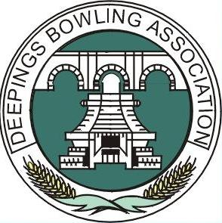
DEEPINGS BOWLING ASSOCIATION
President – Mrs Terri Handley

The Deepings Bowling Association was formed in 1984, by the ‘founder’ members, who were keen to support the sport of Bowling. They were able to lease a piece of land opposite the Leisure Centre on the Spalding Road to use as a Bowling Green and clubhouse. It is due to their hard work that we now have the Club today.

Our membership is drawn mainly from the Deepings but not exclusively so. We welcome potential members who want to play or learn to play the game of bowls.

The Club programme offers all levels of players an opportunity to enjoy the game. There are many levels of play on offer from friendly games to league and competitive matches and the opportunity to play in County Competitions. The Club also offers an interesting social programme.

The season runs from the end of April to mid September and after paying your membership, provided green maintenance is not in progress, or closed by the Greenkeeper due to inclement weather, you can play every day without further charge, provided always that a rink is available.

The greens are open from Tuesday to Sunday from 10.30am to dusk and on Mondays from 12 noon

There is a dress code. The National Association that the Club has adopted sets this. We call it “grey below the waist and white above” which translated means; the ladies wear regulation grey skirts or grey trousers and white blouses, the men grey trousers and white shirts. When no other matches are being played on the green the dress code is waived and smart casual clothes may be worn. Regulation flat-soled bowls shoes MUST be worn on the green at all times.

You may play 5 times on the payment of £3 per visit, after which you will be asked to join. The fees are:-

 | April |  | May | June | July | August
Full | £55 |  | £53 | £41 | £29 | £12
Junior | £17.50 |  | £17.50 | £12 | £8 | £3
 |  | Non Playing Members £10.00 per annum

If you have paid a visitor’s fee this can be deducted from the subscription.

For further information please contact the Hon. Secretary:-
Alistair Patterson, 26 Aquilla Way, Langtoft, Peterborough PE6 9NN tel. 07947 365567
Or e-mail to deeping.bowls.ass@outlook.com Web Site www.deepingbowls.org.uk/
--------------------------------MEMBERSHIP APPLICATION 2024-------------------------------------

Mr, Mrs etc ………………………… First Name …………………………..

Surname…………………………… Date of Birth (optional)………………………

Address...................................................................................................

...............................................................Post Code…………………

Tel. No. ………………………..................... (Including dialling code) Mobile........................................
E-mail (if available) ...................................................................................
Fee enclosed (please tick)
Junior Membership. .... Social Membership..... Full Membership: ……………

I agree that this personal information may be retained by the club and used to facilitate communication between members and to register members with external bowls competitions which you may express a desire to enter through the club and which may require some or all of the above information. Please note that you have the right at any time to request us to delete any or all of the information we hold about you.

Signature: ……………………………........................................................ Date:……………………………………

